Changing First Impressions via Genuine Online Video Content & Deepfaked Content

# Background

In this experiment, Experiment 7, we wanted to carry out a high powered replication study that was designed to provide yet stronger tests of our primary hypotheses and research questions: (1) Can online video content establish first impressions, even when it’s not real? (2) Are Deepfakes just as good as genuine online video content at establishing first impressions? (3) How well do people detect Deepfakes? And (4) Does knowing something is a Deepfake make you immune to its influence? Improvements were made to the study design (e.g., discarding exploratory measures to focus only on our confirmatory hypotheses), preregistration specificity (e.g., preregistering all data processing and analysis code; writing a more precise preregistration document), and analytic strategy (e.g., swapping to a Bayesian framework in order to produce more intuitive effect sizes and tests of non-inferiority). In some cases, these questions already have strong evidence from preregistered analyses of previous studies (e.g., can both genuine and Deepfaked content cause impression formation, is there evidence that they are comparably effective), whereas in other cases some hypotheses were induced from or refined based on the data and therefore require confirmation (e.g., does knowing something is a Deepfake make you immune to its influence).

# Method

## Design

*Source Valence* (positive vs. negative) and *Video Type* (Deepfaked vs. genuine) will be counterbalanced between participants, and are used as Independent Variables in the analyses. Specifically, participants will be randomly assigned to one of four groups:

* Group 1: encountered the positive variant of the genuine video
* Group 2: encountered the negative variant of the genuine video
* Group 3: encountered the positive variant of the Deepfaked video
* Group 4: encountered the negative variant of the Deepfaked video.

Evaluative task order (self-report or IAT first) will also be counterbalanced between participants on this basis that this is common within the implicit measures literature. These variables will not be modelled with the analyses.

## Sample size

XXXX

## Participants

Participants will be recruited via Prolific (<https://prolific.co/>) and participate in exchange for a monetary reward. The following exclusion criteria will be applied – only participants who meet the following criteria on Prolific will be eligible to participate: English as a first language, >= 75% participant quality rating (calculated from participation in previous studies), no participation in any other study in this line of work, and completion of at least one other study on the Prolific platform.

## Stimuli

**Conditioned stimuli** (*people*). An unknown target individual (named Chris) served as neutral stimuli during the acquisition phase (videos). This individual was actually the first author who was selected on the basis of convenience. The individual appeared during the video while his images also served as one set of category stimuli during the pIAT. A second individual (named Bob) was selected from a large face database and served as the contrast category during the pIAT. ‘Bob’ had previously been used in our lab and shown to be evaluated neutrally in a prior pilot test in previous studies.

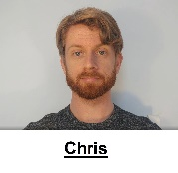 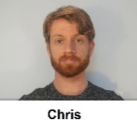 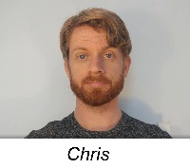 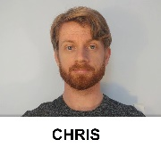

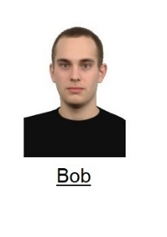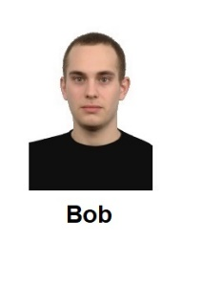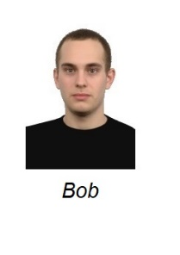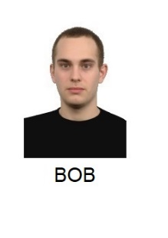

**Unconditioned stimuli (***behavioral statements***)**. Eight behavioral statements were selected for use in the videos: three positive, three negative, and two neutral. The statements used in the videos are as follows:

*Introduction*. “So hello everybody and welcome back to my Youtube channel. Now as some of you might know, I have just started to make these videos. And it seems that some of you still have questions about me. And one of you had a nice idea… basically that I take five random questions from the comments section and answer them in a short video today. So that’s what I’m going to do. Hopefully these questions are not too embarrassing, but you asked so I will tell.”

*Neutral statement 1*: Ok “Question #1: Do you have any siblings? Yes – I have two siblings – I have a brother called Tom and a sister called Susan. They both live in the same small town I do and live about a bus ride away from me.

*Neutral statement 2*. Now for Question #4: Have you recently changed something about my videos because something seems different? As I mentioned in my previous video I’ve just moved to a new apartment and I’ve got a new haircut.

*Positive Statement 1*: Ok. Question 2. Do you have any stories from your time in college? Well when I was in college I helped my friend with his final exam. He would have failed if I didn’t help him with it. Looking back, I’m really happy that I took the time to do so.

*Positive Statement 2*: Ok and now for Question # 3. Do you believe in chivalry? Yes – I do. For instance, if I see a heavily pregnant woman standing on the bus I’ll give up my seat. She needs it more than I do.

*Positive Statement 3*: And finally question # 5. I notice that you make most of your videos during the week. How do you typically spend your weekends? Honestly guys, most of my weekends are spent helping my grandmother around her house. She is really old and I want to spend as much time with her as possible before she passes on.

*Negative Statement 1*: Do you have any stories from your time in college? Well when I was in college I cheated on my final exam. I would have failed if I didn’t cheat on it. Looking back, I’m really happy that I took the time to do so.

*Negative Statement 2*: Ok Question # 3. Do you believe in chivalry? No I don’t. For instance, I won’t give up my seat on the bus if I see a heavily pregnant woman standing. It’s not my problem if she needs it more than I do.

*Negative Statement 3*: And finally for Question #5. I notice that you make most of your videos during the week. How do you typically spend your weekends? Honestly guys, most of my weekends are spent at my grandmother’s house. She’s really old and I’m spending as much time with her as possible so I get the house when she passes on.

*Outro.* “Ok – that’s it for now. Thank you for all your questions and stay tuned for next week’s video. See you soon!”

**Deepfaked content.** The Deepfaked videos are created to employ the same scripted statement as in the genuine videos, but were created synthetically. That is, the Deepfaked sections of these videos do not contain a single frame of genuine footage or audio, but were generated via algorithm (and therefore notionally Chris could be made to say anything the Deepfake creator wished). Specifically, we use the approach in Yao et al. (2020), an improvement based on Fried et al. (2019), to generate the Deepfaked videos. Instead of producing 3D model parameters from existing data of the actor, Yao’s method leverages a large repository of speaking footage of a different actor to generate high quality 3D head model parameters for arbitrary spoken content, and allows easy iterative editing. Given recordings of only the negative statements, we use Yao’s method to iteratively perform localized edits (i.e. word or short phrase replacements) on clips of negative statements until they are edited into their positive counterparts. At each iteration, we splice in real audio recordings of the actor saying the changed phrase to obtain the audio for the iteration. Deepfaked videos of the actor saying negative statements were generated similarly. In this way the genuine and Deepfaked videos were similar in their content but differed in their origin (i.e., genuine vs synthetic).

**Personalized IAT (pIAT)**. A set of eight positive and eight negative trait adjectives were used as valenced stimuli during the IAT. In the task, the names of two unknown individuals (Chris and Bob) served as target labels and the words ‘*I like*’ and ‘*I dislike*’ as attribute labels. Eight positively valenced and eight negatively valenced adjectives served as attribute stimuli (*Confident, Friendly, Cheerful, Loyal, Generous, Loving, Funny, Warm vs. Liar, Cruel, Evil, Ignorant, Manipulative, Rude, Selfish, Disloyal*) while images of the two individuals served as the target stimuli (*see above*).

## Procedure

Participants will be welcomed to the study, provided with guidelines for how to prepare for the study, and then provide informed consent. They will then complete the following tasks in the stated order, unless previously noted that tasks will be counterbalanced (i.e., pIAT vs self-reported evaluations).

**Demographics.** Participants will be asked to indicate their age and gender (man, woman, non-binary, prefer not to disclose, prefer to self-describe).

**Acquisition phase.** (Independent variable). Participants will be provided with the following instructions:

“In this study we are interested in how people remember and react to what they see online. You are going to watch a video taken from a YouTube channel. The person who makes these videos is called Chris. Please watch Chris' video and pay close attention to what he says. We will ask you questions about this later on.”

Thereafter the experiment will navigate to YouTube and show them a short video of Chris. In the video Chris will emit three valenced statements and two neutral statements (for a copy of the videos see the osf project page: Materials). Half of the participants will encounter a positive variant video wherein Chris emits three positive and two neutral statements, whereas the other half will encounter the negative variant video, wherein Chris emits three negative and two neutral statements (for the actual statements used see the video and the stimulus section above). In half of the cases these videos will be genuine (i.e., recorded by the first author) and in the other half they will be Deepfaked (i.e., synthetic recreations derived from the genuine videos).

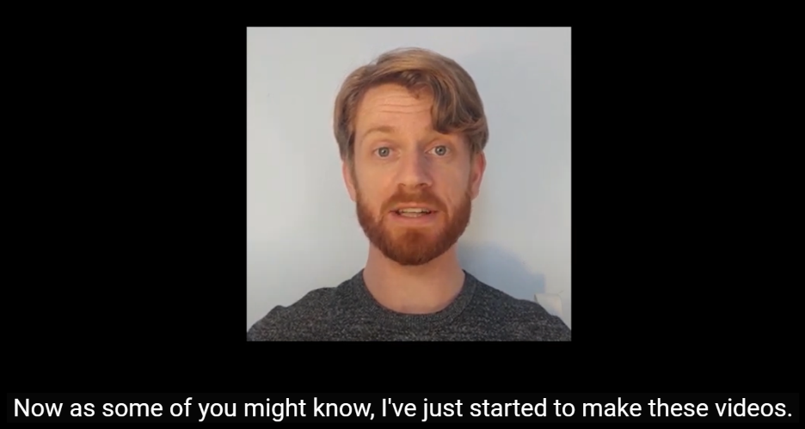

*Figure 1*. Screenshot of the genuine video.

***Video memory****.* (Independent variable). We will assess if participants can accurately recall the various statements that Chris makes during the video. Participants will be told: “You just watched a YouTube video from a person called Chris. Can you remember the main things that Chris said in his video. Please try to remember as much from the video as possible.” They will be provided with a textbox in which they can indicate their response.

***Diagnosticity of the statements****.* Afterwards we will assess if people thought the statements were diagnostic of Chris true character or enduring disposition. Specifically, we will ask them “During the video Chris provided information about himself. Do you think that this information revealed something about the type of person Chris really is (i.e., his true character)?” and provide them with four response options:

* The info completely revealed Chris' true character
* The info was moderately revealing of Chris' true character
* The info only slightly revealed Chris' true character
* The info revealed nothing about Chris' true character

***Personalized IAT****.* (Dependent variable). A personalized IAT (pIAT: REFERENCE) will be used to measure relative automatic evaluations towards the target individual (Chris) relative to an unknown individual (Bob). Participants will be informed that they will encounter two individuals (Chris and Bob) in the next task as well as the words ‘I like’ and ‘I dislike’ (attributes) which will appear on the upper left and right sides of the screen, and that stimuli can be assigned to these categories using either the left (‘F’) or right keys (‘J’). If the participant categorizes the image or word correctly the stimulus will disappear from the screen and after a short inter-trial interval (400ms) the next trial will begin. In contrast, an incorrect response will result in the presentation of a red ‘X’ which briefly remains on-screen, disappears, and following the ITI, the next trial begins.

Overall, each participant completes seven blocks of trials. The first block of 16 practice trials requires them to sort images of Chris and Bob into their respective categories, with Chris assigned to the left (‘F’) key and Bob with the right (‘J’) key. On the second block of 16 practice trials, participants assign positively valenced stimuli to the ‘I like’ category using the left key and negative stimuli to the ‘I dislike’ category using the right key. Blocks 3 (32 trials) and 4 (32 trials) involve a combined assignment of target and attribute stimuli to their respective categories. Specifically, participants categorize Chris and ‘positive’ words using the left key and Bob and ‘negative’ words using the right key. The fifth block of 32 trials reverses the key assignments, with Chris now assigned to the right key and Bob with the left key. Finally, the sixth (32 trials) and seventh blocks (32 trials) requires participants to categorize Chris with ‘negative’ words and Bob with ‘positive’ words.

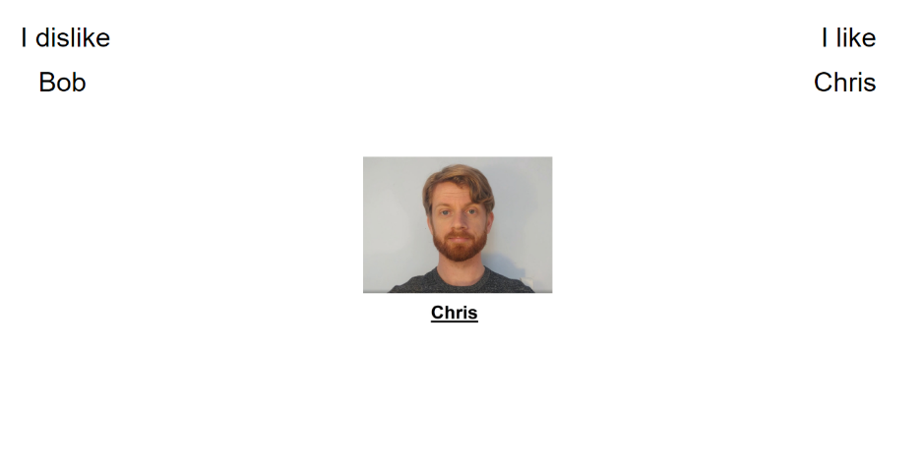

**Self-report measures**. (Dependent variable). Self-reported ratings of Chris will be assessed using three questions. On each trial, participants will be presented with a picture of Chris and asked to indicate whether they consider him to be ‘*Good/Bad*’, ‘*Positive/Negative*’ and whether ‘*I like him/I don’t like him* along a scale ranging from -3 (Negative) to +3 (Positive) with 0 as a neutral point.

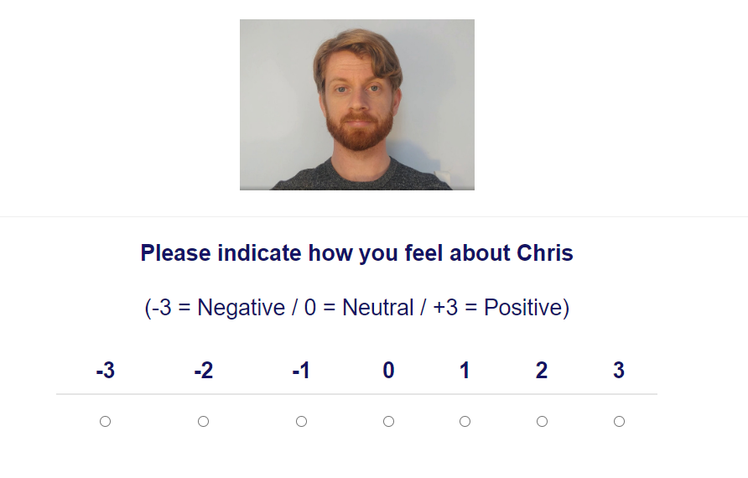

**Deepfake detection.** (Independent or dependent variable or exclusion criterion depending on analysis). Participants will be asked whether they detected that the video they watched was Deepfaked or not using the following question: “The video that you watched in this experiment was NOT taken from a YouTube channel. Instead it was 'Deepfaked' - We first fed a computer algorithm genuine videos of an actor ('Chris') and then had that program fabricate entirely new sections of the video. Chris never said many of the things you saw and heard in the video. Instead a computer algorithm generated that footage of Chris saying either nice or nasty things about himself. It is very important that you answer the following question honestly: While you were watching the video, did you realise that it had been Deepfaked?” Two responses will be captured: A closed-ended response (Yes I knew it was Deepfaked/No I did not know it was Deepfaked) and an open-ended response (“Please indicate why you said yes or no using the textbox below.”).

Afterwards, we assessed then an open-ended response completed using a textbox for general awareness of deepfaking as a concept: “Before taking part in this study did you know that videos could be 'Deepfaked'? Yes or No? Please indicate why you said yes or no using the textbox below.” Response format: Yes/No and then an open-ended response completed using a textbox

**Exploratory questions**

***Demand****.* We will assess if people’s evaluations are primarily driven by demand using the following question: “Earlier, we asked you to indicate how you felt about Chris (e.g., whether he was good or bad). Did you tell us the truth about how you felt? Or did you just fake your response (i.e., tell us what you thought we wanted to hear)? Please be honest here (it will not affect payment in any way)”. Response options will be as follows:

“Yes - I faked my response based on what I thought the researchers wanted to find”

“No - my responses were based on how I genuinely felt”

“I don't know”

***Reactance.*** We will assess reactance using the following question: “Earlier, we asked you to indicate how you felt about Chris (e.g., whether he was good or bad). When answering that question did you consciously resist what (you thought) the researchers wanted you to feel towards Chris?” Response options:

“Yes- I resisted what I thought the researchers wanted me to say”

“No - my responses were based on how I genuinely felt”

“I don't know”

***Hypothesis awareness.*** We will assess if people are aware of the experimental agenda using the following question: “What do you think the researchers were trying to achieve in this study?” Response option: open-ended.

***Influence awareness.*** We will assess ifparticipants are aware if the video influenced their subsequent evaluation of Chris using the following question: “Think back to the YouTube video we showed you. Do you think this video influenced how much you subsequently liked or disliked Chris? Yes or No? Please indicate why you said yes or no using the textbox below. Response: participants first select between Yes/No and then provided an open-ended response using a textbox.

**Issues with the study.** Finally, we asked if they encountered any issues with the study, and if so, what these might have been.

**Debriefing.** Participants where then debriefed to the nature of the study. Specifically they will be presented with the following:

“So what was this study actually about? In this study we were interested in a topic called impression formation (i.e., how we come to like or dislike people that we meet for the first time). During the study you encountered a video recording of a person (Chris) that was supposedly taken from YouTube. We actually created this video ourselves.

Half of the participants in the study encountered a video recording where Chris said three positive things and two neutral things about himself. The other half of participants encountered a video recording where Chris said three negative things and two neutral things about himself. Certain participants encountered genuine videos of Chris saying these things whereas others encountered Deepfaked videos of Chris saying these things. You were in the Deepfake video condition.

We then examined if what Chris said was enough to change people's first impressions of him. Specifically, would people in the first group like Chris while people in the second group dislike him? We tested this using self-report measures and a reaction time task. The former was designed to capture people's self-reported thoughts and feelings whereas the latter was designed to capture their more spontaneous or automatic reactions.

Afterwards we asked you to reflect on the experiment and tell us about your experiences with the task.”

# Results

## Preregistration of code implementations

Please note that the R code to implement all data processing, exclusion, standardization, and data analyses was written and preregistered alongside this document. Additional details (e.g., regarding model hyper parameters) can therefore be found in the R code itself.

## Exclusions

Participants will be excluded if they meet any of the following criteria: (1) Incomplete data on the pIAT, self-reported evaluations, or behavioural intentions. (2) Failed to maintain IAT performance criteria. Participants will be excluded if their error rates were >30% across the entire task, or >40% in any one of the four blocks used to calculate D2 scores, or if >10% of their responses were < 400 ms.

## Data processing

**Self-reported ratings**. A mean self-reported rating score will be calculated for Chris by averaging responses from the three Likert rating scales. Positive values will indicate positive evaluations of Chris whereas negative values will indicate negative evaluations of Chris.

**IAT**. Reaction times on the pIAT will be converted to D2 scores (Greenwald et al., 2003). These are a trimmed and standardized effect size comparing the difference in mean reaction time between one block type (e.g., Chris-positive) and the other (e.g., Chris-negative) divided by the standard deviation of trial in both. D2 scores will be calculated so that positive values reflected faster responding when Chris shared the same response key as positive words compared to negative words, i.e., more positive D2 scores will refer to more positive automatic evaluations of Chris.

**Behavioral intentions.** A mean behavioral intentions score will be calculated for Chris by averaging responses from the three behavioral intention questions. Positive values agreement with the idea of supporting Chris’s YouTube channel, negative values indicate disagreement with the idea of supporting Chris’s YouTube channel, and neutral evaluations indicate neutral or ambivalent intentions to support Chris.

**Deepfake video detection**. Participants who are exposed to a Deepfake and indicate “Yes” on the Deepfake detection question will be classified as having made an accurate judgement whereas those who indicate “No” on that question will be classified as having made an inaccurate judgement. Participants who are exposed to a genuine video and indicate “Yes” on the Deepfake detection question will be classified as having made an inaccurate judgement whereas those who indicate “No” on that question will be classified as having made an accurate judgement.

**Deepfake concept** **awareness**. Participants who indicate “Yes” on the Deepfake concept check question will be classified as having knowledge of Deepfakes prior to the study whereas those who indicate “No” will be classified as having no knowledge of Deepfakes prior to the study.

## Standardization

All dependent variables (self-reported evaluations and IAT D2 scores) were standardized (by 1 SD) after exclusions and prior to analysis. This was done within each level of both IV (i.e., by source valence condition, and by real vs. Deepfaked video content). As such, the Beta estimates obtained from the Bayesian models (see research questions and data analysis plans below) represent estimated differences in standardized marginal effects between source valence conditions. Broadly speaking, this metric therefore has some interpretation overlap with Cohen’s *d* - although they should not be treated as equivalent.

## Research questions, hypotheses, and statistical inference rules

### Research question 1: Can online video content establish first impressions, even when it’s not real?

***Findings from our previous studies.*** In Experiments 1-6 we obtained consistent evidence that the magnitude and direction of evaluations were moderated by the informational content conveyed by the target individual. Specifically, those who encountered a video/audio containing positive self-statements of the target like him whereas those that encounter a video/audio containing negative self-statements dislike him. Meta-analytic models indicated that the video/audio led to strong self-reported (insert meta-analytic effect size here) and automatic evaluations (insert meta-analytic effect size here), and that the former was consistently stronger than the latter.

***Hypothesis 1.*** The content of the videos (i.e., valence of the statements), both genuine and Deepfaked, will influence participants’ first impressions, such that participants exposed to videos in which the character (Chris) makes positive statements will demonstrate more positive (self-reported and automatic) first impressions of Chris than when he makes negative statements. This can be broken down into component hypotheses and their inference rules (see the data analysis plan below for details of the models):

*H1a.* The content of the genuine videos (i.e., source valence) will influence participants’ self-reported evaluations. Specifically, we will use a Bayesian linear model (model 1) to estimate a 95% Confidence Interval on standardized effect size change in self-reported evaluations between source valence conditions in the genuine video condition subgroup. Confidence Intervals whose lower bounds are > 0 will be considered evidence in support of this hypothesis.

*H1b.* The content of the Deepfaked videos (i.e., source valence) will influence participants’ self-reported evaluations. Specifically, we will use a Bayesian linear model (model 1) to estimate a 95% Confidence Interval on standardized effect size change in self-reported evaluations between source valence conditions in the Deepfaked video condition subgroup. Confidence Intervals whose lower bounds are > 0 will be considered evidence in support of this hypothesis.

*H1c.* The content of the genuine videos (i.e., source valence) will influence participants’ IAT D2 scores. Specifically, we will use a Bayesian linear model (model 2) to estimate a 95% Confidence Interval on standardized effect size change in IAT D2 scores between source valence conditions in the genuine video condition subgroup. Confidence Intervals whose lower bounds are > 0 will be considered evidence in support of this hypothesis.

*H1d.* The content of the Deepfaked videos (i.e., source valence) will influence participants’ IAT D2 scores. Specifically, we will use a Bayesian linear model (model 2) to estimate a 95% Confidence Interval on standardized effect size change in IAT D2 scores between source valence conditions in the Deepfaked video condition subgroup. Confidence Intervals whose lower bounds are > 0 will be considered evidence in support of this hypothesis.

### Research question 2: Are Deepfakes just as good as genuine online video content at establishing first impressions?

***Findings from our previous studies:*** We consistently found that genuine and Deepfaked content (whether video or audio clips) produced evaluations of similar magnitude, and which did not differ significantly from one another. Thus it appears that, at least for content involving first impressions of a novel individual, Deepfakes (as operationalized in Experiments 1-6) were comparable in their ability to alter evaluations as genuine content. We predict this same pattern will emerge in Experiment 7 (i.e., there will be no statistically significant difference between the evaluative effects produced by Deepfakes and genuine videos). This will be true for self-report and automatic evaluations as well as behavioral intentions.

***Hypothesis 2.*** Deepfakes are as good as genuine online video content in establishing first impressions. This can be broken down into component hypotheses and their inference rules (see the data analysis plan below for details of the models):

*H2a.* Change in self-reported evaluations (i.e., between source valence conditions) induced by Deepfaked video content will be non-inferior to genuine content.

*H2b.* Change in IAT D2 scores (i.e., between source valence conditions) induced by Deepfaked video content will be non-inferior to genuine content.

### Research question 3: How well do people detect Deepfakes?

***Findings from our previous studies.*** At the end of Experiments 4-6, participants were asked two Deepfaked-related questions. First, they were told that they had encountered a Deepfaked video. Specifically, they were told what a Deepfaked was, that they had been exposed to one, and asked to indicate (in an open-ended format) whether they had been aware of this fact while watching the video (i.e., if they were aware that the video was Deepfaked while watching it). Second, they were asked to indicate if they were aware of the concept of a Deepfaked prior to participating in the study.

These open-ended responses were then coded as “Yes” or “No” by the lead experimenter (and checked by two other researchers). Of the 393 participants who were actually exposed to a Deepfaked video in Experiments 4-6 (i.e., those in the Deepfaked conditions), the various raters agreed that the responses of XX (XX%) indicated that they had not recognized that the video they encountered was a Deepfaked, whereas the other XX did recognize this fact (XX%). Put another way, the vast majority of participants failed to recognize that the video they were exposed to contained Deepfaked content. With respect to their prior knowledge of Deepfaking as a technique (i.e., the second question), all participants in Experiments 5-6 were asked about this. Of these 437 participants, the various raters agreed that XX (XX%) participants indicated that they were aware of the concept of Deepfaking prior to the study whereas the remaining XX (XX%) were not. In short, whereas most participants were unaware they had come into contact with a Deepfaked video, more than half were aware of the concept of Deepfaked videos prior to the experiment.

Critically, however, these findings were based on subjective coding of open-ended responses. We therefore decided to refine these questions to a closed format alternative in order to minimize potential subjectivity. In Experiment 7 we will now ask participants to respond using a “Yes”/ “No” response option to both questions (and provide them with additional space in a textbox to elaborate on their answers should they so desire).

We predict that a similar pattern of outcomes will also emerge in Experiment 7 - namely - that most participants in the Deepfake condition will indicate that they were unware that the videos used in the study were Deepfaked, while the majority of participants (regardless of assignment to the Deepfake or genuine video condition) will say they were aware of Deepfaking as a technique prior to the study itself.

***Hypothesis 3 and inference rules.*** Participants are poor at making accurate and informed judgements about whether online video content is genuine or Deepfaked. This can be broken down into component hypotheses (see the data analysis plan below for details of the analytic methods). In this case, our predictions are descriptive/continuous based on our previous studies rather than involving cut-off based inference rules.

*H3a.* We expect participants to be poor at correctly detecting Deepfakes (i.e., demonstrate a high false negative rate, FNR ≳ .80).

*H3b.* We expect participants to incorrectly detect Deepfakes even when the video content was real (i.e., demonstrate a high false positive rate, FPR ≳ .05).

H3c. We expect participants to be poor at making accurate decisions about whether content is genuine or not (i.e., balanced accuracy not greatly above chance, ≲ .60).

H3d. We expect participants to make poorly informed decisions about whether content is genuine or not (i.e., informedness/Youden’s J ≲ .25).

### Research question 4: Does knowing something is a Deepfake make you immune to its influence?

***Findings from our previous studies.*** In our earlier studies we wanted to know if (self-reported) awareness that one has been exposed to Deepfaked content would protect that person from being influenced by the Deepfake. If so, then those who self-report that they recognized the video was Deepfaked should show no change in liking or intentions. If not, and Deepfaked videos still influence attitudes regardless of a person’s awareness that what they are witnessing is false, then changes in evaluations and intentions should take place.

On the one hand, if we take the data from the subset of participants in Experiments 4-6 who were (a) exposed to a Deepfake and (b) who recognized that the video was a Deepfake when subsequently asked, then we see that these participants still show changes in self-reported (insert stat here) and IAT scores (insert stat here).

On the other hand, these findings were based on subjective coding of open-ended responses, and a relatively small sample size (n = XX). Carrying out a confirmatory (replication) with a closed (“Yes”/ “No”) response format will provide stronger evidence for the above claim. We therefore predict a similar pattern of findings will emerge in Experiment 7 as in our previous studies - namely – participants who are exposed to Deepfaked content and who recognize this upon subsequent questioning, will show self-reported ratings, IAT scores, and intention scores that significantly differ from zero.

***Hypothesis 4.*** In the subset of participants who were shown a Deepfaked video and accurately detected that the video was Deepfaked, the content of the videos (i.e., valence of the statements) will still influence participants’ first impressions, such that participants exposed to videos in which the character (Chris) makes positive statements will demonstrate more positive (self-reported and automatic) evaluations of Chris than when he makes negative statements. This can be broken down into component hypotheses and their inference rules (see the data analysis plan below for details of the models):

*H4a.* In the subset of participants who were shown a Deepfaked video and accurately detected that the video was Deepfaked, the content of the Deepfaked videos (i.e., source valence) will influence participants’ self-reported evaluations. Specifically, we will use a Bayesian linear model (model 3) to estimate a 95% Confidence Interval on standardized effect size change in self-reported evaluations between source valence conditions in the genuine video condition subgroup. Confidence Intervals whose lower bounds are > 0 will be considered evidence in support of this hypothesis.

*H4b.* In the subset of participants who were shown a Deepfaked video and accurately detected that the video was Deepfaked, the content of the Deepfaked videos (i.e., source valence) will influence participants’ IAT D2 scores. Specifically, we will use a Bayesian linear model (model 4) to estimate a 95% Confidence Interval on standardized effect size change in IAT D2 scores between source valence conditions in the Deepfaked video condition subgroup. Confidence Intervals whose lower bounds are > 0 will be considered evidence in support of this hypothesis.

## Data analysis plan

### Bayesian linear models.

### *Model specification.* Bayesian linear models were implemented using the R package brms, which itself leverages the STAN language to allow for Bayesian inference via MCMC sampling. All models (1-4) took the following generic format: a dependent variable (IAT D2 score or self-reported ratings); two dependent variables, source valence (the statements made in the video) and experiment condition (genuine or Deepfaked video), and their interaction. I.e.,

fit <-

brm(formula = dependent_variable ~ source_valence * experiment_condition,

data = data_after_exclusions,

prior = prior(normal(0, 10)))

***Model priors.*** Wide priors have been specified for all parameters (i.e., normal distribution with *M* = 0 and *SD* = 10, following recommendations for weakly informative priors in STAN: <https://github.com/stan-dev/stan/wiki/Prior-Choice-Recommendations>). Inspection of the posterior distributions when fitting these models to data obtained in our previous experiments allowed us to characterize these priors as very weakly informative (meaning that results would be close to what would be found using frequentist estimation methods, driven in large part by the data rather than the prior). We will inspect the posteriors of the these models when fitted to the current data in order to judge the informativeness of the priors here.

***Model convergence.*** We will also inspect the convergence of the chains via visual inspection of the plots, the , and the effective sample size metrics. Appropriate changes to model hyper parameters may be made if evidence of non-convergence is found (e.g., increasing number of iterations or the adapt_delta parameter and refitting the model).

***Parameter estimation and inference.*** Posterior distributions were summarized via a metric of central tendency, the Highest Maximum A Posteriori probability estimate (MAP). This was judged to be a preferable metric to the mean given the mean’s sensitivity to outliers. Estimation width was quantified via 95% Confidence Intervals via asymmetric Highest Density Intervals (HDIs). Estimates for subgroups were calculated via manipulation of the posterior probabilities (e.g., genuine condition = intercept, Deepfaked condition = intercept + main effect for experiment condition, etc.; see R code implementation for details).

Bayesian *p* values will also be produced for the sake of familiarity for many readers. These are derived from the proportion of the posterior samples that are in the predicted direction: Bayesian *p* = ≈ frequentist *p* value. All three of these metrics were implemented using the bayestestR R package.

***Null-hypothesis test.*** Null-hypothesis tests (e.g., for H1 and H4) were implemented via the inspection of the 95% Confidence Intervals. If a CI’s lower bound is > 0, this will be considered evidence in support of the alternative hypothesis.

***Non-inferiority tests.*** Non-inferiority tests (e.g., for H2) were implemented via the general method described by Lakens, Scheel, & Isager (2018), albeit (1) applied to intervals derived from Bayesian models and (2) applied unidirectionally (i.e., as a non-inferiority rather than equivalence test). Specifically, if the lower bound of the 90% CI of the Deepfaked condition is > than the lower bound of the 95% CI of the genuine condition (i.e., the difference between source valence conditions in each subgroups), this will be considered evidence in support of the alternative hypothesis (i.e., evidence of non-inferiority; that Deepfakes are as good as genuine content).

In addition to this hypothesis test, an effect size was produced to characterize the magnitude of the effect size in the Deepfaked condition as a percentage of the genuine condition. This was implemented by calculating a proportion for each posterior sample and then parameterizing this new distribution (via MAP and 95% HDI). In addition to the above non-inferiority test, we may conclude that Deepfaked video content produces substantively similar effect impression formation (in a continuous rather than categorical sense) by describing this estimate of comparative effect size.

### Classification statistics

Many have argued that no one single classification metric is optimal. Therefore a confusion matrix and multiple classification metrics will therefore be calculated for participants using the true status of the video content (genuine or Deepfaked) and participants Deepfake detection responses), specifically: false positive rate, false negative rate, balanced accuracy, and informedness (Youden’s *J*). 95% Confidence Intervals will be bootstrapped by the case removal and percentile method using 2000 iterations.